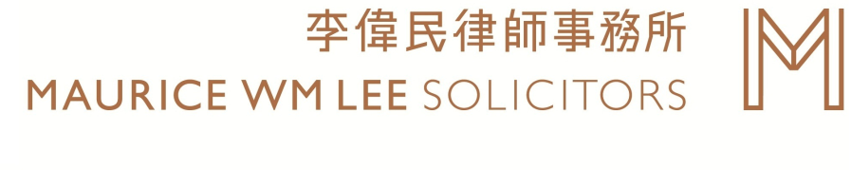

Issue 68/09

Misconduct in Public Office
(公職人員行為失當法律)

Introduction (簡介)

The former Chief Executive of Hong Kong Donald Tsang’s case in respect of the above offence attracted public attention. Many would like to know more about the law.

As public officers (公職人員) of a government, they are entrusted with the powers to serve the community and uphold public interests. However, the law requires that the public officers shall not commit wrongful acts, from bribery to acts arising from conflict of interests or abuse of official position.

The Misconduct in Public Office (“MIPO”) is not a statute law. It is a common law (判例法律) offence which targets at all forms of serious abuse of office by public officials.

The Law (法律原則)

What are the key elements (五大元素) of MIPO?
In Sin Kam Wah and another v HKSAR (FACC 14/2004), the Court of Final Appeal held that the test for the common law offence of MIPO includes 5 requirements. The offence of MIPO will be committed where:
- a public official;
- in the course of or in relation to his public office;
- wilfully misconducts himself; by act or omission (for example, by wilfully neglecting to perform his duty);
- without reasonable excuse or justification; and
- where such misconduct is serious and not trivial, having regard to the responsibilities of the office and the office-holder, the importance of the public objects which they serve and the nature and extent of the departure from those responsibilities.

In addition, the conduct in question must be deliberate or reckless i.e., the official either knows that the conduct is unlawful; or wilfully disregards the risk that the conduct may be unlawful.

A public officer may commit MIPO even if there is no bribery or pecuniary gains (受賄或金錢利益) involved if the above requirements are satisfied.

Who is a “public officer” (公職人員) and is every “public officer” liable?
In HKSAR v Wong Lin-kay (FACC 3/2011), it was held that under the offence of MIPO, a public officer must be conferred powers, discretions or duties exercisable by virtue of his official position for the public benefit.

Therefore, although every employee in the public sector may be termed a “public officer”, not every one of them was susceptible to liability for MIPO if one’s job does not vest him with any relevant power to be exercised for the benefit of the public. For example, a low-rank truck driver hired by the government may not have a public office entrusting him with powers or discretions to be exercised for the public benefit. His work is just daily chore. So, in general MIPO may not be applicable to him.

What is the punishment of committing the offence of MIPO (罰則)?
A public officer who is convicted of the offence of MIPO is punishable under section 101I(1) of the Criminal Procedure Ordinance (Cap. 221) (刑事訴訟程序條例), and is liable to a maximum penalty of seven years of imprisonment and a fine.

Examples of MIPO

During 2000-2011, disciplinary and related actions were taken against some civil servants who were convicted of MIPO. Examples of the types of misconduct include:

- circumvention of government procurement or tendering procedures
(規避採購或招標程序)
(e.g. awarding contracts to bidders without following the usual procedure or favouring parties with personal relationship)

- wrongful exercise or abusive use of official authority
(不當行使或濫用權力)
(e.g. using the power of one’s official position for personal gains)

- unauthorized disclosure of classified information
(未經授權披露機密資料)
(e.g. obtaining privileged information for others)

- dishonest claims
(不誠實的申領)
(e.g. deliberate claims of government subsidy with knowledge of the claims being false)

Conclusion (總結)

This article provides a general outline of common law offence of the MIPO. The offence of MIPO has a considerable historical foundation, which had existed in England since 1704. There seems to be some legal ambiguity when defining a “misconduct”. It may be desirable for the present offence to be codified by the legislature in order to provide a clearer standard and guideline for the public officers to precisely follow.

MAURICE WM LEE SOLICITORS
李偉民律師事務所

Nothing shall constitute advice to any person by Messrs. Maurice WM Lee Solicitors (Tel: (852) 2537 5833) (Website: www.wmleehk.com)
No person shall rely on the contents without our prior written consent. We assume no liabilities
Copyright ©2017 Maurice WM Lee Solicitors
本文所載的內容均不構成李偉民律師事務所(Tel: (852) 2537 5833) (website: www.wmleehk.com)的意見
未經我們事先書面同意, 任何人不得使用上述內容. 本所不承擔有關責任
©2017李偉民律師事務所版權所有
If you do not wish to receive our newsletter, please contact our Administration Manager at info@wmleehk.com or (852) 2899 6605.
如閣下不欲收取本事務所的通訊，請電郵至info@wmleehk.com或致電(852) 2899 6605與行政經理聯絡。

